

Year 11 Specialist Mathematics
Semester 1 2020
Test 1: Combinatorics and Introduction to Proofs
Weighting: 6%
Resource Free Section
[Australian Curriculum Reference Numbers: 1.3.1-1.3.5, 1.1.1-1.1.9, 2.1.5]

Student Name: SOLUTIONS Teacher:________________________
Time: 25 min Total Marks = $\frac{}{27}$
Instructions:
You ARE NOT allowed any notes or calculator.
You will be supplied with a formula booklet.

- Consider the statement:
“If a quadrilateral has all four sides with equal length, then it is a square”
  - State the inverse of the statement.
$$If a quadrilateral doesnt have all 4 sides with equal length, then it is not a square$$



  - State the converse of the statement.
$$If a quadrilateral is a square then it has all 4 sides with equal length$$
  - Is the contrapositive of statement true or false? Justify your answer.

It is false
$$If a quadrilateral is not a square then it doesnt have all 4 sides with equal length$$
Counterexample: Rhombus

[1,1,2 = 4 marks]
- A pencil case contains a variety of red, blue, black, and green pens.

  - How many pens do you need to have to be certain of having three pens of the same colour?
$$R B B G$$
$$2 2 2 2 + 1 = 9 pens$$

  - What is the smallest number of pens you can have in the pencil case to ensure you have at least 4 red pens, or 3 green pens, or 2 blue pens, or 5 black pens?
$$R B B G$$
$$3 1 4 2 + 1 = 11 pens$$


[2,2 = 4 marks]






  - Prove the following by proving its contrapositive:
$$∀ p∈Z,p^{2}even⇒p even$$
$$R.T.P: If p is odd⟹p^{2}is odd$$
$$If p is odd then p=2k+1, where k∈Z$$
$$∴p^{2}={\left(2k+1\right)}^{2}$$
$$p^{2}=4k^{2}+4k+1$$
$$p^{2}=2\left(2k^{2}+2k\right)+1$$
$$∴p^{2}must also be odd$$
$$Since we have shown that p is odd⟹p^{2}is odd , \\ then its contrapositive must also be true$$
$$Hence, {if p}^{2} is even, then p must be even$$
Q.E.D





  - Hence prove the equivalence statement:
$$∀ p∈Z,p^{2}even⇔p even$$
$$p^{2}even⟹p even has been proven above.$$
$$Need to prove the converse ie. p even ⟹p^{2}even$$
$$If p is even then p=2k, k ∈Z$$
$$p^{2}={\left(2k\right)}^{2}=4k^{2}=2(2k^{2})$$
$$∴p^{2} is also even by definition.$$

$$Both the original statement and its converse have been proven$$
$$Hence p^{2}even⟺p even$$
Q.E.D

[5,5 = 10 marks]

- Evaluate the following:

  - ${}_{}^{10}{P_{3}}$
$$=\frac{10!}{7!}=10×9×8=720$$


  - ${}_{}^{12}{C_{8}}$
$$\frac{12!}{4!8!}=\frac{12×11×10×9}{4!}$$
$$=\frac{12×11×10×9}{24} = 495$$

[1,3 = 4 marks]



- Determine the value of ${}_{}^{n-1}{P_{2}}$ if it is known that $7×{}_{}^{n}{P_{2}=6× }{}_{}^{n+1}{P_{2}}$ for $n>0.$
$$7×\frac{n!}{\left(n-2\right)!}=6×\frac{\left(n+1\right)!}{\left(n+1-2\right)!}$$
$$7×\frac{n\left(n-1\right) ×\left(n-2\right)!}{\left(n-2\right)!}=6×\frac{\left(n+1\right)\left(n\right)×(n-1)!}{\left(n-1\right)!}$$
$$7×n\left(n-1\right)=6×n(n+1)$$
$$7\left(n-1\right)=6(n+1)$$
$$7n-7=6n+6$$
$$n=13$$

$$∴{}_{}^{12}{P_{2}}=12×11=132$$

[5 marks]
*** End of Resource Free Section ***



Year 11 Specialist Mathematics
Semester 1 2020
Test 1: Combinatorics and Introduction to Proofs
Weighting: 6%
Resource Rich Section
[Australian Curriculum Reference Numbers: 1.3.1-1.3.5, 1.1.1-1.1.9, 2.1.5]
Student Name:_______________________________ Teacher:________________________
Time: 25 min Total Marks = $\frac{}{23}$
Instructions:
You ARE allowed a ClassPad calculator and/or scientific calculator.
You ARE NOT allowed any notes.
You will be supplied with a formula booklet.

- The school’s mixed basketball squad consists of 6 girls and 4 boys.
  - How many teams are possible if you must have more girls than boys on a team of 5 players?

3 girls: $\left({6 \atop 3}\right)×\left({4 \atop 2}\right)=120$

4 girls: $\left({6 \atop 4}\right)×\left({4 \atop 1}\right)=60$


5 girls: $\left({6 \atop 5}\right)×\left({4 \atop 0}\right)=6$
$$∴186 possible teams$$

  - The school’s mixed basketball team won its tournament and is getting a photo taken with all 10 players. How many photos are possible if the photo consists of two rows of 5, and the captain Emma must be “front and centre” with the vice-captain Hashva and MVP Alex on either side of her?
$$7 6 5 4 3$$
$$2 [H E A] 1$$

$$=2×7!=10080$$

[4,3 = 7 marks]


  - How many “words” can be formed using the letters from the word SLEEPLESS if you must use every letter?
$$=\frac{9!}{3!3!2!}=5040$$







  - How many 4-letter “words” can be formed using the letters from the word SLEEPLESS?
$$All different:\left({4 \atop 4}\right)×4!=24$$
$Two S^{'}s only:\left({3 \atop 2}\right)×\frac{4!}{2!}=36$ $Two S^{'}s and Two L's:\frac{4!}{2! 2!}=6$
$Two L^{'}s only:\left({3 \atop 2}\right)×\frac{4!}{2!}=36$ $Two L^{'}s and Two E's:\frac{4!}{2! 2!}=6$
$Two E^{'}s only :\left({3 \atop 2}\right)×\frac{4!}{2!}=36$ $Two E^{'}s and Two S's:\frac{4!}{2! 2!}=6$
$$Three S's:\left({3 \atop 1}\right)×\frac{4!}{3!}=12$$
$$Three E's:\left({3 \atop 1}\right)×\frac{4!}{3!}=12$$
$$∴174 four letter words$$





  - How many 4 letter ‘words’ can be made from the word $EQUALS$ if $Q$ must be followed by $U$, and you cannot have $QU$ last?
$$Q not chosen: \left({5 \atop 4}\right)×4!=120$$
$$QU chosen: \left({4 \atop 2}\right)×3!=36$$
$$QU Last: 4×3×1×1=12$$
$$∴4 letter words=120+36-12=144$$
[2,5,4 = 11 marks]

- There are 255 Year 11 students at Melville Senior High School. Of these students, 68 study Physics and 44 study Computer Science. 29 students study Chemistry and Physics, 14 study Physics and Computer Science and 19 study Computer Science and Chemistry. 9 students study all 3 subjects and 120 students study none of these subjects.
Use the inclusion-exclusion principle to determine the probability that a Year 11 student chosen at random studies chemistry but not Physics or Computer Science.
$$255 students-120=135 studying atleast one of the subjects$$
$$\left|Chem∪P∪CS\right|=\left|Chem\right|+\left|P\right|+\left|CS\right|-\left|Chem∪P\right|-\left|P∪CS\right|-\left|Chem∪CS\right|+\left|Chem∩P∩CS\right|$$


$$135=|Chem|+68+44-29-14-19+9$$
$$|Chem|=76$$


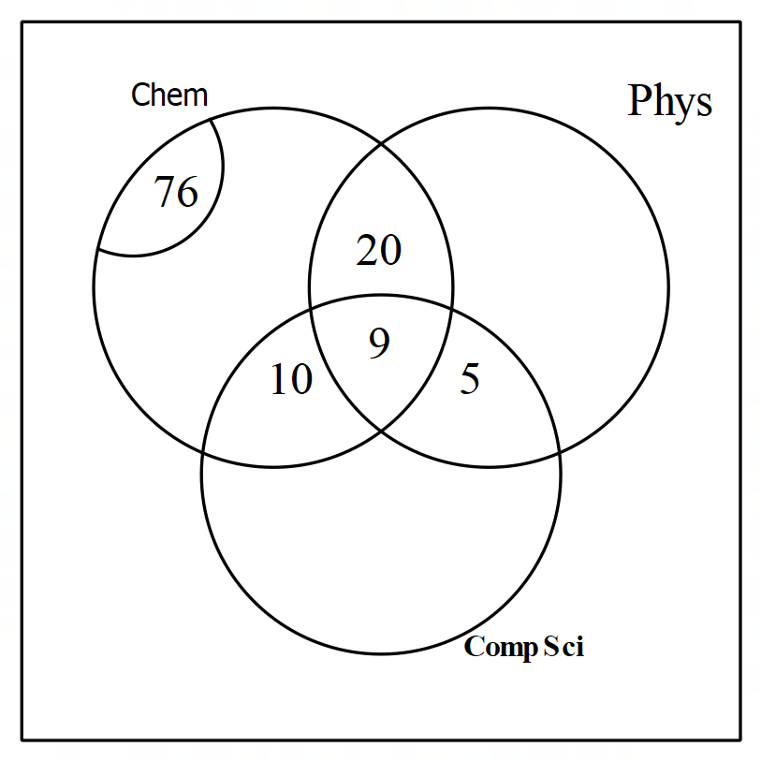 ∴ 37 study Chem only
$$Pr(Chem only){=\frac{37}{255}}$$
**Deduct 2 Marks of Inclusion Exclusion Principle not used **
[5 marks]
*** End of Resource Rich Section ***

